SHREDDER RACKS - ASSEMBLY AND INSTALL INSTRUCTIONS

“Awesome”, you have purchased a Shredder Rack!

Over the years at Shredder Racks we have continued to improve the Shredder rack. The latest modification is the hinge. This offers many options for setup to achieve optimum position allowing access to the rear of the vehicle whether it is a hatch or a ute with a tailgate. There are some limitations on swing doors.

ATTENTION: The “Shredder Rack” has multiple setup positions – as vehicle types and tow bars can vary, the closer the Shredder Rack is to the rear of the vehicle the better for rigidity. Please follow instructions to achieve optimum setup.

As a last option, cutting modification may need to be done on the 50mm insert tube.

The new hinge design allows the hinge to rotate 180 degrees and move forward or back on the insert tube (see pictures 1-4). This allows 4 x set positions with different offsets.

We have attached a couple of views and photos for final assembly, and setup of the clamp.
All fastenings are supplied – possibly in a spare hole for shipping.

TIPS:
We suggest assembling upside down as it sits on the pallet.
Don’t do the final tighten on nuts and bolts until all final set up is complete.

Rack Assembly and Install:

When you receive your Shredder Rack the hinge / post position may not be the optimum setup position – it is setup for freight purposes at a generic fitting.

- Remove 50mm insert tube from freight position, test in your towbar receiver to make sure 17mm retaining hole lines up. I suggest using the in most position for all bike racks. If your towbar is blind or blanked off by the cross beam, the first hole on the insert tube should still line up.
- Return and loosely secure insert tube to hinge/post.
- Remove post and hinge only from freight position and insert into towbar receiver in upright position (see pictures 1-4).
- The hinge has a stop bolt and plastic packer (see pictures 5-6)

Ute set up
NB: 16mm bolt always remains in rear hinge hole – see pictures 1-4
- Remove nylon stop and lay post back to bolt stop – this is 45 degrees (picture 5).
- Lay tailgate down slowly to full stop position.
- Assess the tailgate – post clearance and move hinge forward / back as a unit in receiver or move / rotate hinge on insert tube to achieve minimal clearance (see pictures 1-4)
NOTE: Nylon wear strips need to move accordingly with the hinge.
Proceed with install from Step 5

SUV / Hatch / Sedan set up
NB: 16mm bolt always remains in rear hinge hole – see pictures 1-4
- Leave nylon stop in position and lay post back to stop – this will be 30 degrees (picture 5). If clearance not achieved remove nylon stop.
- Lift door slowly to full open position.
- Assess clearance and move hinge forward / back as a unit in receiver or move / rotate hinge on insert tube to achieve clearance (see pictures 1-4 below) on post.
NOTE: Nylon wear strips need to move accordingly with the hinge.
Proceed with install from Step 5

Towball Rack set up (then follow Steps 5 – Step 8)
NB: 16mm bolt always remains in rear hinge hole – see pictures below and attached
- The new hinge design allows the hinge to be rotated 180 degrees and to move forward and back 25mm on the towball adaptor (see separate pictures attached)
This allows 4 set-up positions with different offsets.
- Assess any rear door opening clearance and move hinge forward / back as a unit on the towball adaptor (see separate pictures attached)
- The best setup is to have the post as close to the towball as possible.
- All towball racks must use tieback straps to secure the rack back to the vehicle (supplied)
- Ensure all pinch bolts are secure including anti-rotation bolts.
NOTE: Nylon wear strips need to move accordingly with the hinge.
Proceed with install from Step 5

- When hinge and post are set up remove and fit to top beam / hoops (upside down on pallet)
- Insert tube needs to be pointing the same way as the long side of the hoops or opposite shredder sticker on top hoop rail. See pictures 7-8
- Bottom rail bolts are fixed to top of post for freight purposes only. Mount bottom rail to post, generally 700-800mm between top rail and bottom rail. See pictures 7-8
- The tie back eyelet nut can be used at the position the rack is received in or moved to another bolt point e.g. bottom rail fastening bolt or any spare hole on post - use the spare bolt supplied (fixed to top of post) if relocating the tie back eyelet nut.
- Remove any plastic guard/cover if fitted to your towbar Receiver Tube.
- Fit Shredder Rack to vehicle, insert 16mm pin.
- Select amount of packers (black) required (see picture 9), 1 or 2 for clamp (this is determined by thickness of Receiver Tube).
- “SECURE LOCKING CLAMP – CLAMP MUST BE USED” PLEASE MAKE SURE THIS IS DONE AS PER THE PHOTO BELOW AND CALL ME OR SEND A PHOTO FOR VIEWING IF YOU ARE HAVING ANY ISSUES WITH ENSURING THAT THE RACK IS FITTED TIGHTLY INTO THE TOW BAR

20” Adaptor Info only
- Holes at ends of bottom rail are for mounting 20” adaptor kit.
- A packer bolt is fixed through the hoop ‘V” and this is to raise the front wheel height so forks do not contact hoop and cause any damage.
- The supplied clamp to restrict 20” wheel from coming back to much in hoop. There is no set position for clamp, as long as the fork is clear of the hoop.

Additional Notes:

Make sure all fastenings are tight before loading.
Load bikes from left to right and unload in reverse order.
Bungies to retain wheels are pre-set, but can be adjusted accordingly on top and bottom rails to fit specific wheels.
Always use supplied clamp.
We recommend using tie back straps if fully loaded, especially when hitting the open road and long hauls. The racks are built strong however the strength of your vehicle towbar receiver / road conditions / weight of e-bikes etc can mean that your receiver or towbar may be damaged if there is any impact. The tieback straps significantly reduce the rack movement and rigidity on the vehicle and towbar receiver.

Plan your bike sequence at home and set all bungies, once have a bike load sequence, it’s so easy and fast. Bungies don’t need to be max tight, have enough stretch to allow easy removal of fingers when securing bike onto rack, especially on the winter rides when fingers are cold.

Please contact me if you have any questions,

Craig Rutherfurd |Director
SHREDDER RACKS LIMITED
Mobile 027-747-3337


SHREDDER RACKS – PHOTOS OF TOW BAR RACK SETUP

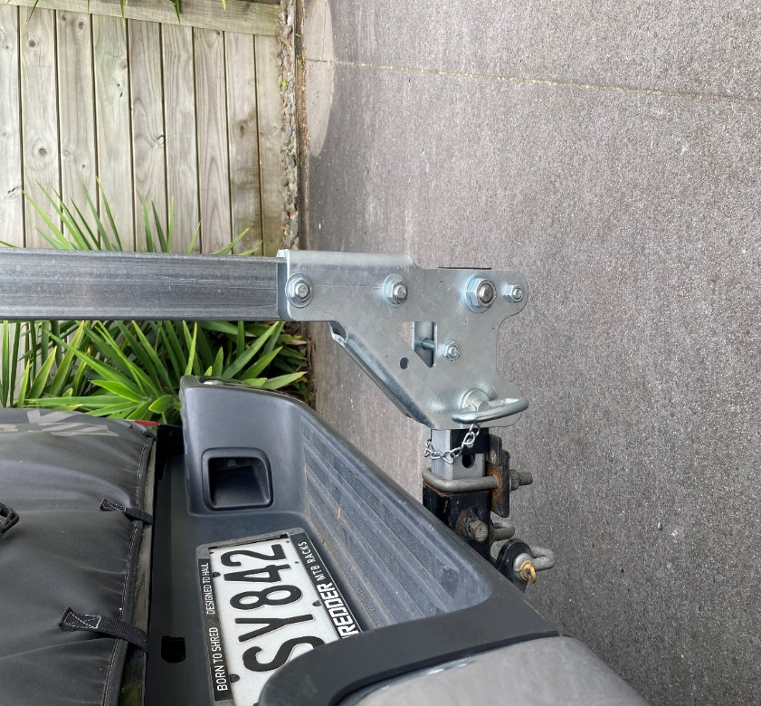
      - Hinge and post in upright position

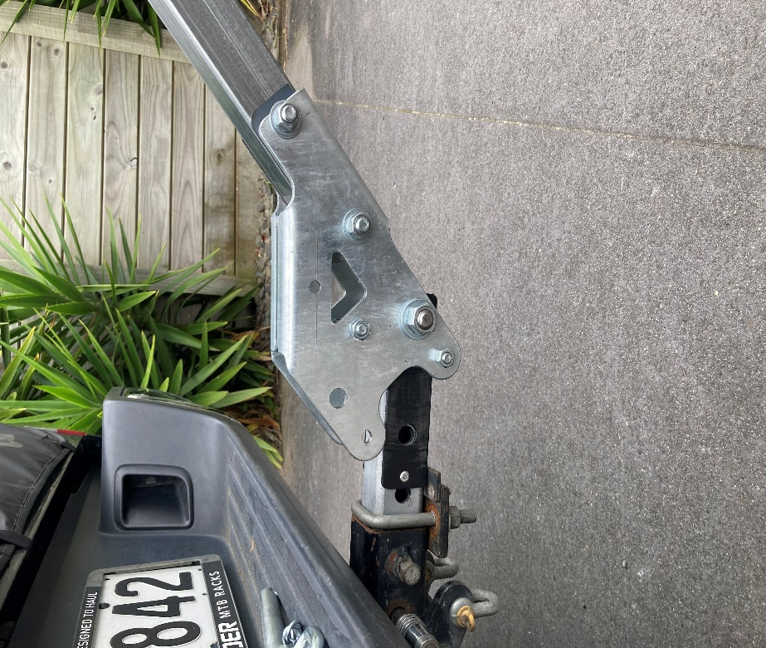
      - Hinge and post in lay back position to 2 stops - 45 degrees as pictured or 30 degrees

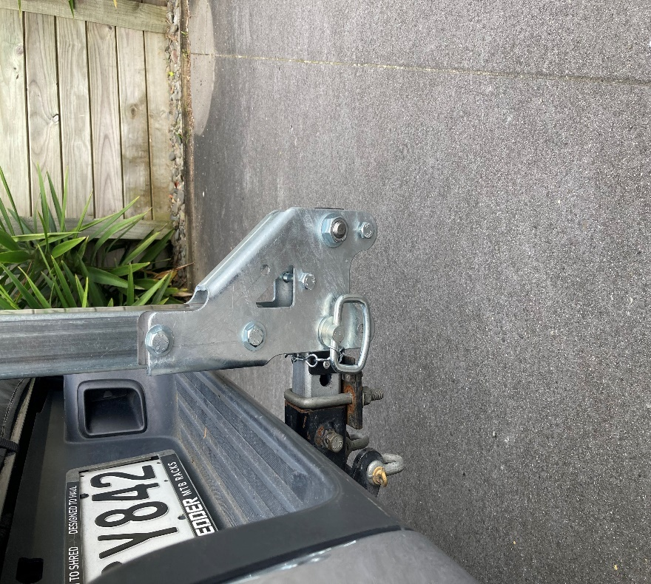
      - Hinge and post rotated 180 degrees to be closer to rear of vehicle (if required)

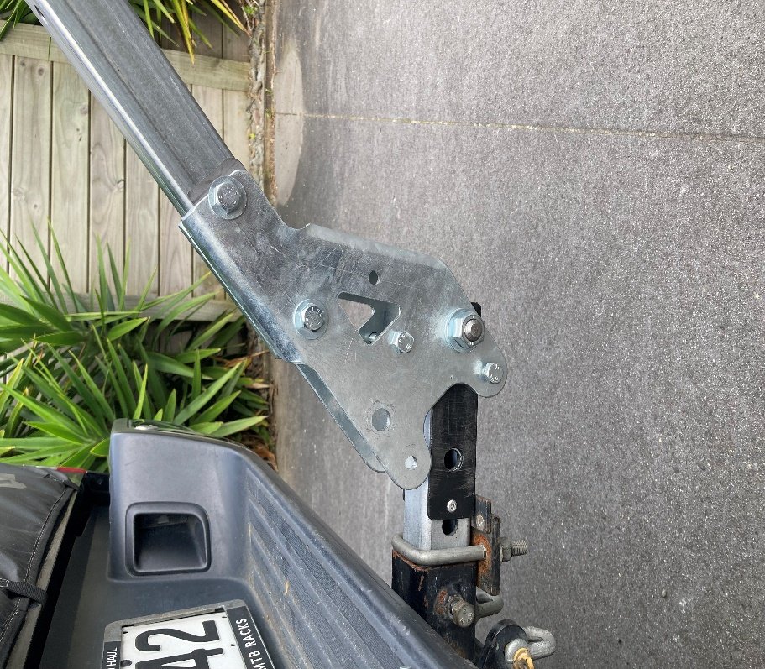
      - Hinge and post in lay back position to 2 stops - 45 degrees as pictured or 30 degrees
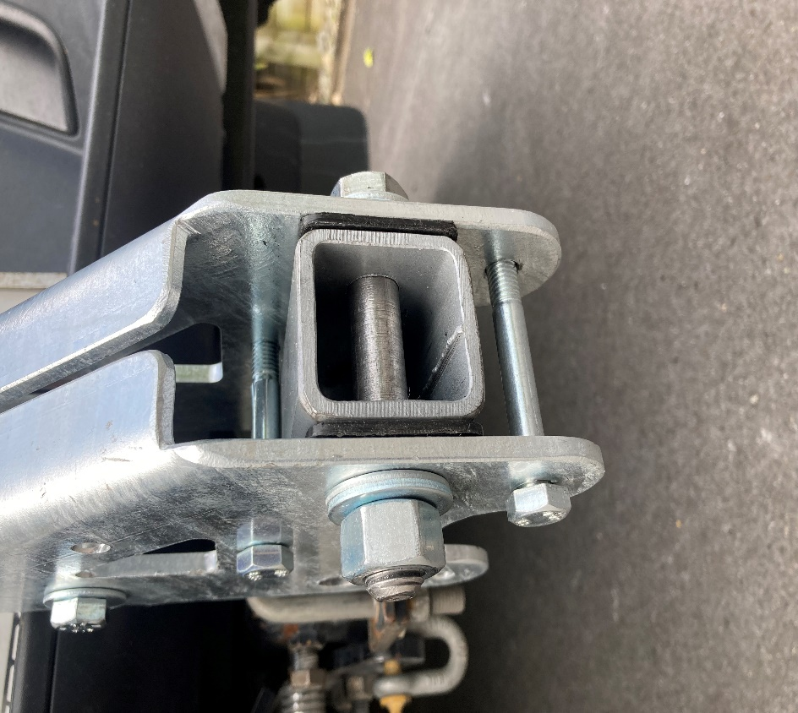
      - Remove nylon stop to allow rack to lie back to 45 degrees. If remove stop completely rack will lie back horizontal.

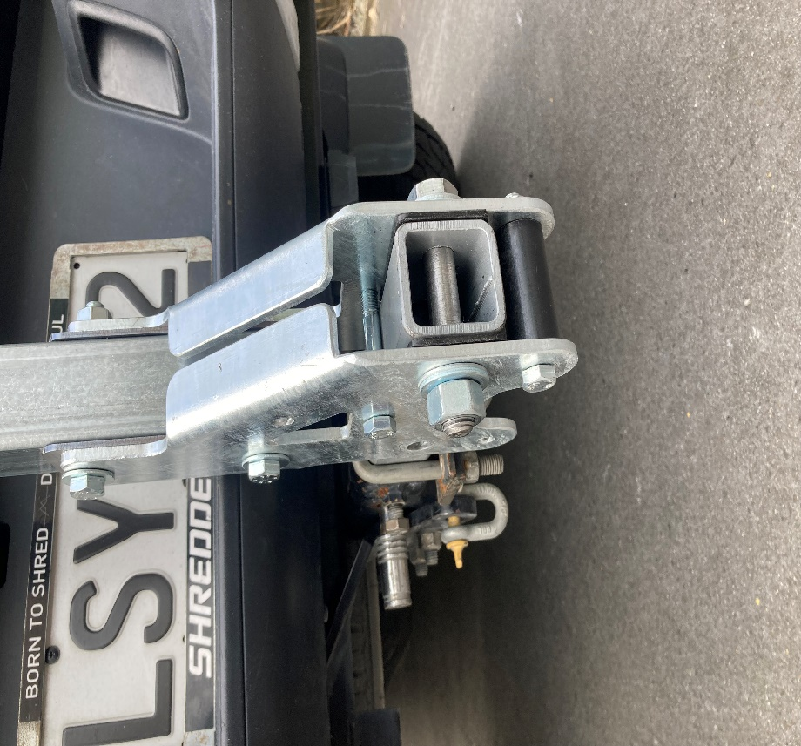
      - Nylon on stop allows rack to be laid back to 30 degree stop.

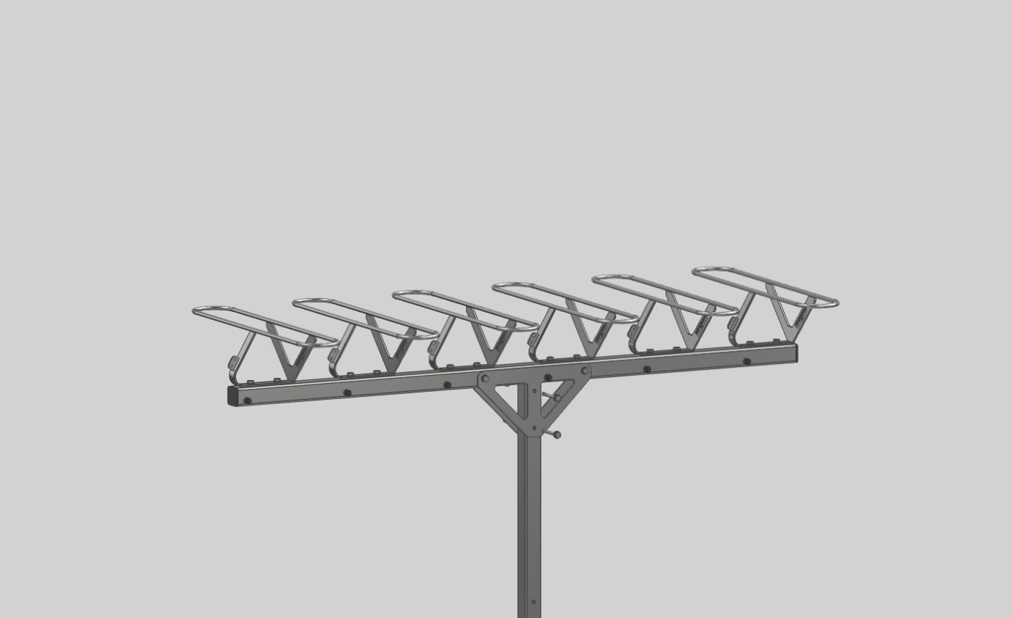 7. Secure post to top tube through brace

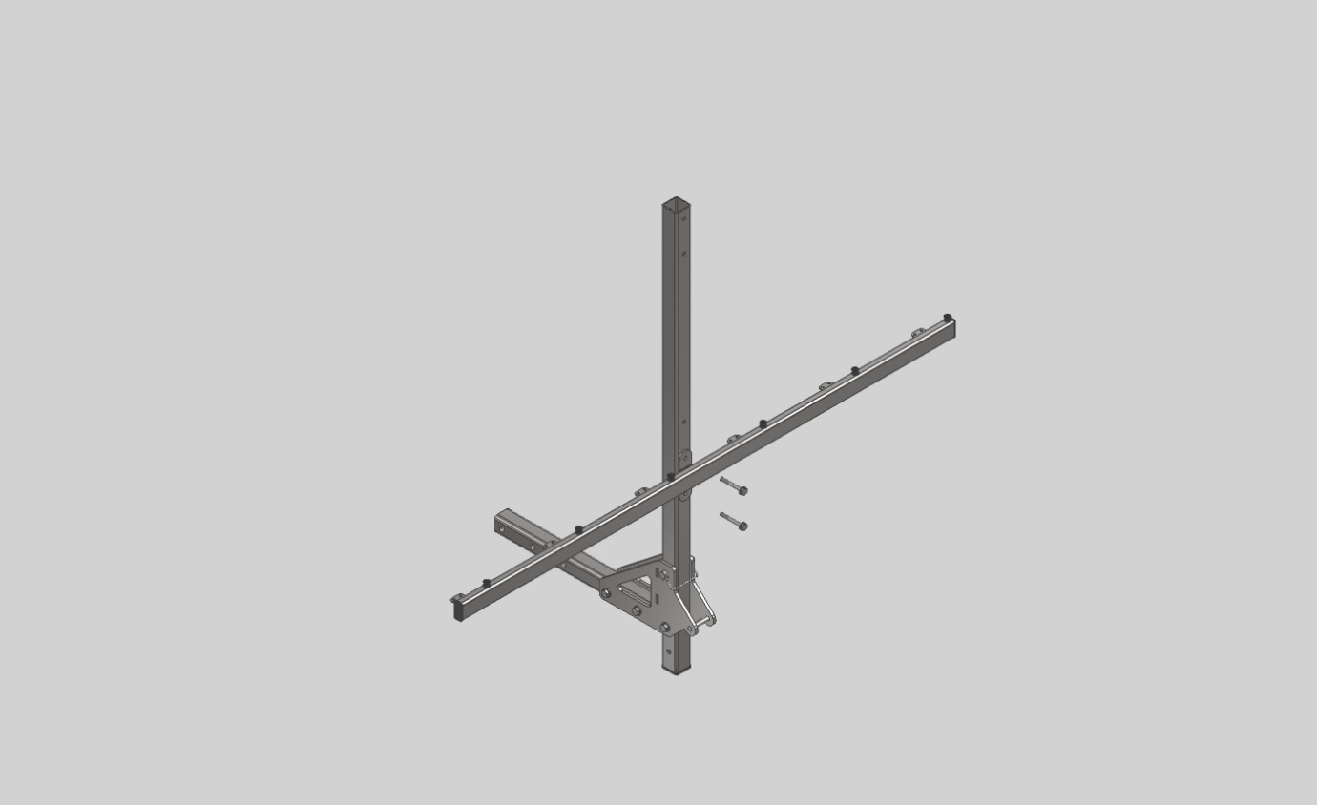
8. Secure bottom rail in holes that best suit length of bikes – generally 700-800mm

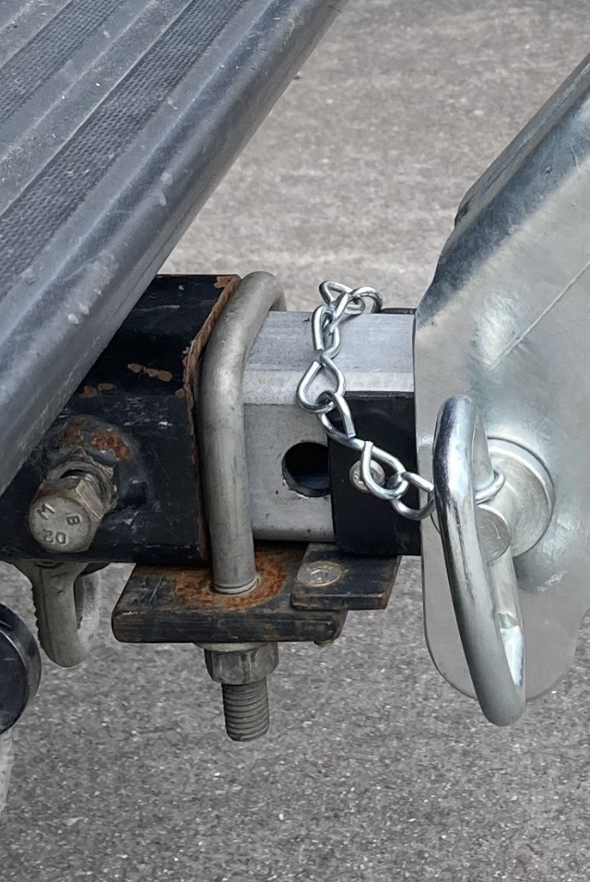
9. Correct setup of clamp plate

